**Class Notes**

**Questions**

**Class 6: Wednesday November 28th**

**Class 5: Monday November 26th**

Resources for Future Use

* Jon Duckett books
* Eloquent JavaScript
* Code School

Typography

Properties

* Line height
* font size
  + px
  + em (relative to parent container)
  + rem (relative to document size)
  + vwh (responsive to browser size)
* line length
* letter spacing
* sans serif vs. serif

Google Fonts

* load times are an important consideration for UX
* Chrome extension: whatfont

Pseudo Classes

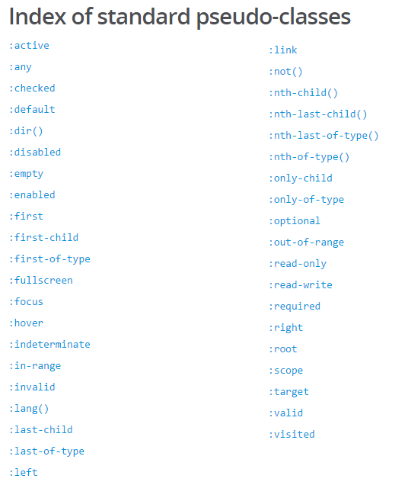

* hover
  + use transition property to make changes more visible (see the change in hover state as opposed to jumping immediately)
* active: element engaged (e.g. being clicked on, typed in, etc.)
* focus: doesn’t need to be active, tabbing through elements one way to stimulate focus without being active

Bootstrap

**Class 4: Monday November 19th**

HTML semantics

* Using specific tags makes it easy for machines to digest the importance of the content from the human perspective

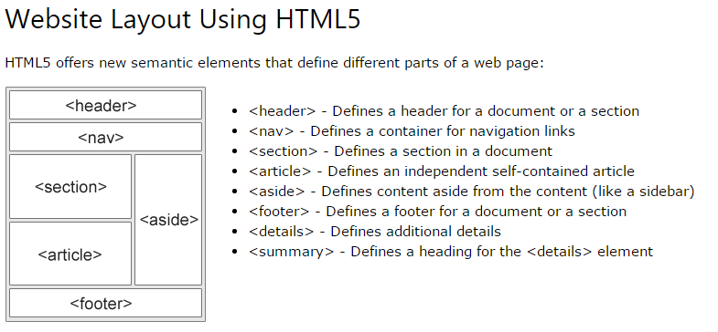

* Difference between classes & IDs
  + IDs are one-time use (and can be used to link directly to the ID in the page)
  + Classes are used for multiple HTML elements

Multiple CSS files

* Browser will read multiple files in chronological order as one giant .css
* loading order MATTERS, CSS reads top-to-bottom, don’t want to conflict and end up with undesirable result

CSS Resets

* What is it? A file that returns every CSS style to “0”, removes all formatting
* Why use one? It is a tool for cross-browser functionality
  + *guessing we reset to zero BEFORE adding our styles to remove any browser-specific formatting?*

Deploying Sites

**Class 3: Saturday November 17th**

How to style HTML? CSS of course!

* Elements (called using element name: p { applies to all <p> tags )
* Classes (called using a period: .container { )
* 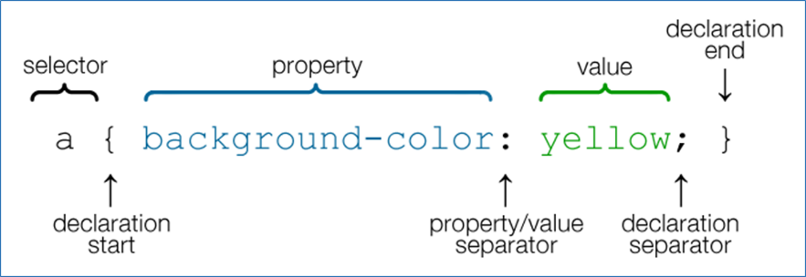IDs (called using a hashtag: #id { )

Relative vs. Absolute file paths

* Relative paths direct the browser to files within the working directory
* Absolute file paths direct the browser to a specific file
  + This is okay for files hosted online (e.g. URLs to images), but do not use absolute file paths to link to files/images on my machine

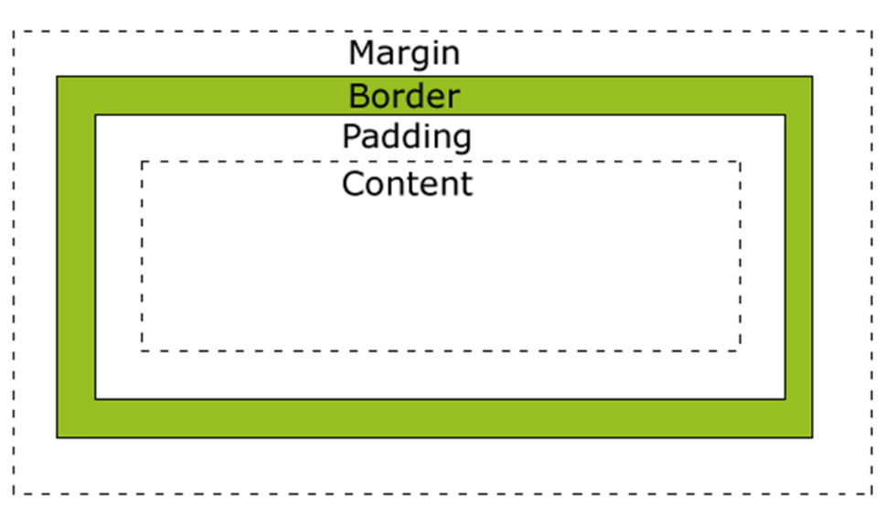

Box Model

* Elements in CSS work using a “box model” with variables like margin, padding and border
* box-sizing: makes it easier to make a box model the size you actually want it to be
  + e.g. make my box 400px x 400px, and factor in the margins/padding/borders from there to end with a 400px x 400px
  + benefits of this: if I need to create a page with specific-sized boxes, I can use box-sizing instead of having to calculate heights/widths including padding/margins/borders
  + <https://www.paulirish.com/2012/box-sizing-border-box-ftw/>

Floats

* Floats are a great tool to create “flow” on your webpage
* Functionally like text wrapping, turns block elements into inline elements (see below)

Block elements vs. inline elements

* most elements are Block Elements, which take up an entire line of space (unless otherwise specified)
* 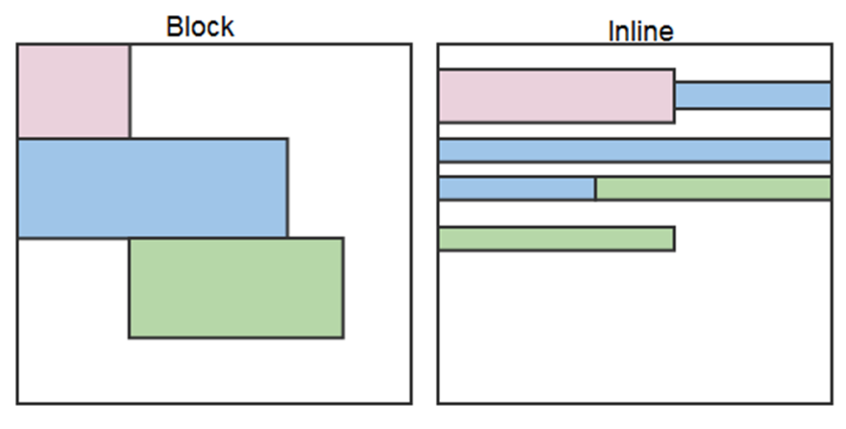inline elements flow one after another

Clearing the Float

* using floats can mess with the layout in ways we don’t want, especially re: the height of our containers
* 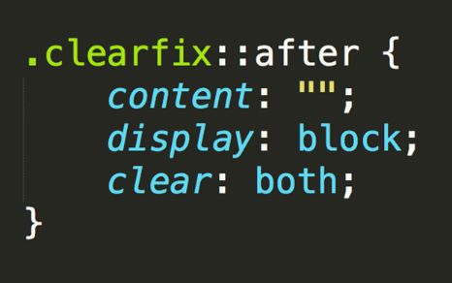To fix this, we can use the clearfix “hack”:

[All About Floats by Chris Coyer, CSS-Tricks](https://css-tricks.com/all-about-floats/)

* Four float values:
  + left (float left)
  + right (float right)
  + none (element doesn’t float)
  + inherit (assumes float value of parent element)
* clear is the sister property of float, also has four values
  + both (clears floats coming from both directions)
  + left (clears floats from the left)
  + right (clears floats from the right)
  + none (doesn’t clear at all)

CSS positioning

Position types

* Static (default)
* Relative (positioned relative to other elements in the container, NOT taken out of the flow of the page)
* Absolute (taken out of the flow, specific positions relative to nearest positioned ancestor)
* Fixed (positioned on specific coordinates in the browser window)

Layering

* z-index: use large gaps to give yourself room to add elements in between
  + e.g. use 100 and 200 instead of 1 and 2, if I need to add something else, can use 150 instead of having to rename every single layer

Display

* Display: none will hide elements

Expand on overflow

Flex Box

<http://jonibologna.com/content/images/flexboxsheet.pdf>

<https://www.youtube.com/watch?v=jV8B24rSN5o&feature=youtu.be>

<https://www.youtube.com/watch?v=jV8B24rSN5o&feature=youtu.be>

**Class 2: Wednesday November 14th**

Working with GitHub

What is GitHub?

* A web-based platform that stores code online
* Serves as a backup to local machines
* Useful tool for collaborative coding
* Users pull (download) or push (upload) code to/from a GitHub repository
* Major benefit of working through GitHub: version control

Version Control

What is it?

* Developing code in installments (think of it like saving a document in multiple versions as you work on it) 🡪 Version 1, Version 2, etc.

Why is it helpful?

* Version control makes it a lot easier to work collaboratively
  + Easy to track who has worked on what
  + Easy to ensure you’re working with the latest code
* Segmenting your code makes it clearer which portions of code are creating problems
  + E.g. if Version 3 worked fine but Version 4 has problems, the coding errors reside in what was added in Version 4

Basic Git commands

* git clone = download a repository from GitHub to your local directory
* git add = first step, prepares a file to be committed to the GitHub repository
* git commit = commits a file to GitHub repository (use “-m” to write a message annotating the change)
* git push = sends changes to the online GitHub version
* git pull = downloads the latest version of a GitHub repository

HTML

* Headings factor into SEO
* HTML tags resource: <http://www.w3schools.com/tags/>

CSS

* when modifying elements using CSS, use a period for classes and a hashtag for IDs
  + e.g. if a class is called ‘container’, we’d refer to it as .container in CSS
  + e.g. if an ID is called ‘main_bio’, we’d refer to it as #main_bio in CSS

**Class 1: Monday November 12th**

# Bash / Terminal Commands

These are the basic commands for navigating directories in a Terminal or Git Bash window

*Moving in directories*

* Change Directory = cd
* Change to Home Directory = cd ~/
* Move to One Directory Up = cd ..
* View Folders and Files in the Directory = ls
* Show the current Directory = pwd
* Autocomplete a File Name in the Current Directory = Press `tab` key once to autocomplete once you have typed a unique portion of a file name

*File Manipulations*

* Make New File = touch [name of file to create]
* Make New Folder = mkdir [name of directory to create]
* Delete file = rm [name of file to remove]
* Delete folder = rm -r [name of directory to remove]
* Copying File = cp [filename1] [filename2]
* Move/Rename File = mv [filename1] [filename2]
* Open file or folder (PC only) = explorer [name of file]
* Open all files and folder in current directory (PC Only) = explorer .